H.T No
Regulations:
A19

Sreenidhi Institute of Science and Technology
(An Autonomous Institution)
Code No: 7W208 Date: 19-Sept-2022 (FN)

M.Tech I-Year II-Semester External Examination, Sept/Oct-2022 (Regular/Supplementary)
ADVANCED CAM (CAD/CAM)

Time: 3 Hours Max.Marks:70

Note: a) No additional answer sheets will be provided.
b) All sub-parts of a question must be answered at one place only, otherwise it will not be valued.
c) Missing data can be assumed suitably.

ANSWER ANY FIVE QUESTIONS. EACH QUESTION CARRIES 14 MARKS.

Bloom's Cognitive Levels of Learning (BCLL)
Remember | L1 | Apply | L3 | Evaluate | L5
Understand | L2 | Analyze | L4 | Create | L6

 |  |  | BCLL | CO(s) | Marks
1. | a) | Explain the Adaptive control System and how do you Classify it. | L3 | CO1 | [7M]
 | b) | Extrapolate Quick Change tooling System used in CNC. | L4 | CO1 | [7M]
2. | a) | List the Major functions of Post Processor. | L3 | CO2 | [7M]
 | b) | List out the Major variables in the DAPP based Post Processor. | L3 | CO2 | [7M]
3. | a) | List various logic conditions and ladder diagram for each with suitable example. | L3 | CO3 | [7M]
 | b) | Enumerate hardware components required for PLC setup for automation. | L4 | CO3 | [7M]
4. | a) | Summarize the Geometry Statements in APT Part Programming with neat diagrams. | L6 | CO4 | [7M]
 | b) | Generate the NC Part Program for the Given Figure below.  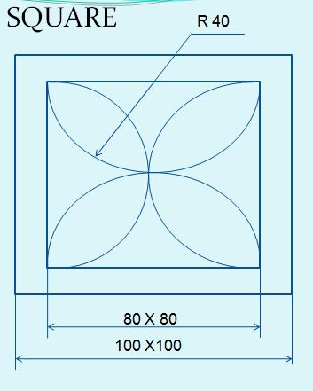 | L5 | CO4 | [7M]
5. | a) | State the Key Aspects of CAM in a Manufacturing System. | L4 | CO5 | [7M]
 | b) | Explain various Features based methodoligies used in CAM . | L3 | CO5 | [7M]
6. | a) | Extrapolate the Optical Inspection Methods used under Computer aided inspection. | L5 | CO6 | [7M]
 | b) | List out the Applications of Genetic Algorithm. | L2 | CO6 | [7M]
7. | a) | What is adaptive control system with Optimization? | L2 | CO1 | [5M]
 | b) | Summarize the flow chart for general structure of Post Processors. | L3 | CO2 | [5M]
 | c) | List the various types of microcontrollers available in the market. | L5 | CO3 | [4M]
8. | a) | Explain MACROS used in APT Part Program. | L4 | CO4 | [5M]
 | b) | Explain the Feature recognition System. | L4 | CO5 | [5M]
 | c) | Elaborate Expert systems Technologies. | L4 | CO6 | [4M]
-- 00 -- 00 –

